Fast Algorithms and the FEE Method

E.A. Karatsuba

I. FAST ALGORITHMS

The field of computational mathematics, which is called Fast Algorithms, was born in 1960. By an algorithm, not formalizing this concept, we mean a rule or a way of computation.
We assume that numbers are written in the binary form, the signs of which 0 and 1 are called bits.

Def.1. Writing down of one of the symbols 0,1,+,-,(,), putting together, subtraction and multiplication of two bits is called an elementary operation or a bit operation.

Fast Algorithms is the field of computational mathematics that studies algorithms of evaluation of a given function with a given accuracy, using as few bit operations as possible. Thus the algorithms, which, can be called fast ones, are real algorithms. Realizing such algorithms in software (and sometimes in hardware) it is possible to increase essentially the computer's efficiency, and sometimes to solve problems of the size that didn't permit a
solution by means of ordinary methods of computation. The question of the size of a problem, which can be solved in a certain time with the help of a given computer, leads us to the concept of complexity of computation.

The problem of bit complexity of computation was first formulated by
A.N.Kolmogorov http://www.kolmogorov.com/
(1956) [36], [37], who emphasized at the same time, that ‘… the series of my works on information theory was created in the 50s and 60s under a strong influence of publications by Norbert Wiener http://www-groups.dcs.st-and.ac.uk/~history/Mathematicians/Wiener_Norbert.html and Claude Shannon http://www-groups.dcs.st-and.ac.uk/~history/Mathematicians/Shannon.html …’ Before we introduce the concept of complexity of computation, we define what it means to evaluate a function at a given point.

Consider the simplest case: let y = f(x) be a real function of a real argument x , a ≤ x ≤ b , and assume that f(x) satisfies on (a,b) the Lipschitz condition of order α , 0 < α < 1 , that is for x₁, x₂ ∊ (a,b) :
|f(x₁) - f(x₂)| ≤ | x₁ - x₂ |^{α} .

Let n be a natural number.

.
Def.2. To compute the function y = f(x) at the point x = x₀ ∊ (a,b) up to n digits means to find such a number A, that

| f(x₀) – A | ≤ 2⁻ⁿ.

Def.3. The total number of bit operations sufficient to compute the function f(x) at the point x = x₀ with accuracy up to n digits by means of a given algorithm, is called the complexity of computation of f(x) at the point x = x₀.
up to n digits. Thus, the complexity of computation of f(x) at the point x = x₀ is a function of n; and so are f(x) and x = x₀ .

This function is denoted by

s_{f}(n) = s_{f,x0}(n).

It is clear that s_{f} depends also on the algorithm of calculation and for different algorithms will be different. The complexity of a computation is directly related to the time that the computer needs to perform this computation. For this reason, the complexity is often treated as a 'time' function T(n) [35].

The problem of behaviour s_{f}(n) as n → ∞ for a class of functions or for a particular function f,
was for the first time formulated by Kolmogorov around 1956. Since in computations the four arithmetical operations, namely, addition, subtraction, multiplication and division are used in the first place, one needs to know the number of bit operations sufficient for performing these operations. Definitions 2 and 3 imply that the numbers
x₀ and A can be represented in the form of the integral part and n binary digits after the binary dot,i.e.,

A = [A] + 0,ν₁ν₂ ν₃ …ν_{n},
x₀ = [x₀] + 0,μ₁μ₂μ₃ …μ_{n},

where ν_{j}, μ_{j} = 0 or 1 , j = 1, 2, … , n.

Since the integral parts [A] , [x₀] are fixed and n → ∞ , the operations are, in fact, performed on n -
digit integers. Therefore, first of all there is a problem of estimating the complexity of calculation of the sum, difference, product, and quotient of two n -digit integers a and b.
Note that division (with a remainder) reduces to addition, subtraction and multiplication of numbers. To write down the numbers a and b one needs at least 2n bit operations. Consequently, the complexity of addition (subtraction) of a and b is not less than 3n bit operations, and not more (when doing it in an ordinary manner) than 4n
bit operations. Hence, the order of the number of bit operations which are necessary and sufficient for
putting together and subtracting is the same.

In what follows we call the bit operations simply operations, omitting the word bit.

The next problem is the problem of the total number of bit operations sufficient for computing the product ab,
or the problem of complexity of multiplication. The function of complexity of multiplication has the special notation
M(n).

Multiplying two n -digit numbers in the ordinary school way, ‘in column’, we actually put together in this case n n –digit numbers. So for the complexity of this ‘school’ method or ‘ordinary’ method we get the upper bound
M(n) = O(n²).

In 1956 A.N.Kolmogorov formulated the conjecture, that the low bound for M(n)
for any method of performing the multiplication is also of order n² (the so-called Kolmogorov
'n² -conjecture'). The fact that the method of multiplication ‘in column’ has been known at least for 4 thousands years (for example, this method was used by summers), so that if there existed a faster method of multiplication, it would have been most likely already found, was an argument in favour of the 'n² -conjecture'.
In 1960 A.Karatsuba http://www.mi.ras.ru/~karatsuba/index_e.html
[19], [20], [21] (see also [35]) found a method of multiplication with the complexity bound

M(n) = O(n^{log 23} ), log ₂ 3 = 1,5849… ,

and thus disproved the 'n² -conjecture'. Later the method was called ‘Divide and Conquer’; the other names of this method, used at the present, are ‘Binary Splitting’, ‘Dichotomy Principle’ etc.

The appearance of the method ‘Divide and Conquer’ was the starting point of the theory of fast computations. A number of authors (among them Toom http://www.de.ufpe.br/~toom/ [48], Cook http://www.cs.toronto.edu/~sacook/[15], and Schőnhage http://www.informatik.uni-bonn.de/~schoe/index.html
[43]) continued to look for an algorithm of multiplication with the complexity close to the optimal one, and in 1971
Schőnhage and Strassen www.physicsdaily.com/physics/Volker_Strassen
[44], [45] constructed an algorithm with the best known (at present) upper bound for M(n),

M(n) = O(n log n log log n).

In the construction of this algorithm, apart from ‘Divide and Conquer’, they used the idea of realizing arithmetic operations modulo the Fermat numbers 2^{2ⁿ} +1, and the Fast Fourier Transform.

On the basis of the method ‘Divide and Conquer’ the algorithms of fast matrix multiplication were constructed. Strassen [47] was the first to find such algorithm in 1970, later these
investigations were continued by Coppersmith http://www.research.ibm.com/people/c/coppersmith/ and Winograd
http://researchsmp2.cc.vt.edu/DB/db/indices/a-tree/w/Winograd:Shmuel.html [16], Pan http://comet.lehman.cuny.edu/vpan/ [41] and others.
Approximately at the same time the first algorithms of calculation of elementary algebraic
functions started to appear. As it was already mentioned before, the division of the number a by the number b with residue, that is the calculation of the numbers q and r in the formula

a = qb + r , 0 ≤ r < b,

is reduced to addition-subtraction and multiplication, and if a and b are n -digit numbers, then the complexity of division is O(M(n)).
The simplest algorithm of division is to compute the inverse value 1/b with accuracy up to n digits by the Newton method and after that to multiply by a using the fast multiplication algorithm.
Assume that we must find x = 1/b, where 1/2 ≤ b ≤ 1 (if this is not true, then multiplying or dividing by 2^{N} we obtain the example under consideration). As an initial approximation we take x₀ = 3/2 and calculate by formula

x_{n+1} = 2x_{n} - bx_{n}².

This method provides sufficiently fast convergence to 1/b, since from the equality
x_{n} = 1/b - ε, it follows x_{n+1} = 1/b - bε².

For taking the root of k -th degree from a number, that is for the calculation of a^{1/k}, it is also possible to use the Newton method. Assume k ≥ 2 is an integer and we must compute x = a^{1/k}, where a ≥ (k+1)^{k}. We compute x by the formula:

x_{n+1} = (k+1)x_{n} /k – (x_{n}^{k}⁺¹)/(ka).

Note that multiplying or dividing by 2^{kN}, one can always get the condition a ≥ (k+1)^{k} (sometimes this condition is unnecessary, because the indicated process converges fast for other a, either). As an initial approximation it is possible to take, for example, one of the numbers d or d+1, where d is the integer that satisfies the condition d^{k} < a ≤ (d+1)^{k}. The complexity of the calculation is also O(M(n)).

First fast algorithms of computation of elementary algebraic functions based on the Newton method appear in the works of Cook [15], Bendersky http://www.bisguard.com/ [8] and Brent http://web.comlab.ox.ac.uk/oucl/people/richard.brent.html [11] (see also [35]). Using Newton's method, it is possible to prove also the following theorem ([11]):

Theorem. If the equation f(x) = 0 has a simple root ζ ≠ 0, f(x) is Lipschitz continuous in the neighborhood ζ ,
and we can compute f(x) with accuracy up to n digits by O(M(n)ϕ(n)) operations,
where ϕ(n) is a positive, monotone increasing function for any x from a neighborhood of ζ,
then it is possible to calculate ζ with accuracy up to n digits also by O(M(n)ϕ(n)) operations.

In 1976 Salamin http://www.ams.org/mathscinet-getitem?mr=53+%237928 [42] and Brent [11] suggested first algorithm for fast evaluation of the constant π based on the AGM-method of Gauss (see, for example, [13], [14]). Using also the ascending transformations of Landen http://www-groups.dcs.st-and.ac.uk/~history/Mathematicians/Landen.html [38], Brent [11] suggested the first AGM -algorithms for evaluation of elementary transcendental functions. Later many authors have been going on to study and use the AGM -algorithms. Among those authors were the brothers Jonathan Borwein http://www.cs.dal.ca/~jborwein/
and Peter Borwein http://www.cecm.sfu.ca/~pborwein/, who wrote the book ‘The Pi and the AGM’ [9], where the greatest number of AGM -algorithms were collected. Apart from the algorithms of calculation of elementary transcendental functions, in this book there were also algorithms for evaluation of some higher transcendental functions (the Euler Gamma function,for example). To compute such functions with accuracy up to n digits using the algorithms described in the book one needs

O(n^{3/2} log³ n log log n)

operations.

About some other results connected with ‘Divide and Conquer’ and fast calculations see [1], [2], [3], [6],[7], [17], [18], [35], [40].

II. THE FEE METHOD

1. Introduction. Definition of a fast algorithm

An algorithm of computation of a function f = f(x), is said to be fast, if for this algorithm

s_{f}(n) = O(M(n) log^{c} n) ,

where c is a constant. Here and below we assume that for M(n) the Schőnhage-Strassen bound holds. It is obvious that for any algorithm and any function f, the inequality

s_{f}(n) > n

is valid. (Note that recording some number with accuracy up to n digits requires itself not less than n+1 operations.) Therefore, for fast algorithms

n < s_{f}(n) < c₁ n log^{c+1}n loglog n < n^{1+ε}

for any ε > 0 and n > n₁(ε). That is, for the fast computational algorithms the order of upper bound of s_{f}(n) in
n , n → ∞, is correct.

The method FEE (since 1990) [22]—[34] (see also [4]—[6], [39]) is at present the second known method (after the AGM) for fast evaluation of classical constants e and π, and elementary transcendental functions. But, unlike the AGM, the FEE is also the method for fast computation of higher transcendental functions.
At present the FEE is the unique method, permitting to calculate fast such higher transcendental functions as the Euler Gamma function, hypergeometric, spherical, cylindrical etc. functions for algebraic values of the argument and parameters, the Riemann zeta function for integer values of the argument and the Hurwitz zeta function for integer values of the argument and algebraic values of the parameter.

2. Calculation of the constant e.

The main idea of the method FEE is explained in the easiest way by the example of calculating the classical constant e. To begin with, we consider the algorithm of computation of n! in log n steps with the complexity

O(n log³ n log log n).

For simplicity we assume that n = 2^{k} , k ≥ 1.

Step 1. Calculate n/2 products of the form:

a₁(1) = n(n-1) , a₂(1) = (n-2)(n-3) , … , a_{n/2}(1) = 2*1 .

Step 2. Calculate n/4 products of the form:

a₁(2) = a₁(1)a₂(1) , a₂(2) = a₃(1)a₄(1), … , a_{n/4}(2) = a_{n/2}(1)a_{n/2-1}(1) .

… etc.

Step k, the last one. Calculate one product of the form:

a₁(k) =a₁(k-1)a₂(k-1) .

This gives the result: n!

For the evaluation of the constant e take m = 2^{k} , k ≥ 1, terms of the Taylor series for e,

e = 1 + 1/1! + 1/2! + … + 1/(m-1)! + R_{m} .

Here we choose m, requiring that for the remainder R_{m} the inequality R_{m} ≤ 2⁻ⁿ⁻¹ is fulfilled. This is the case, for
example, when m ≥ 4n/log n. Thus, we take m = 2^{k} such that the natural number k is determined by the
inequalities: 2^{k} ≥ 4n/log n > 2^{k}⁻¹.
We calculate the sum

S = 1 + 1/1! + 1/2! + … + 1/(m-1)! =

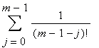

in k steps of the following process.

Step1. Combining in S the summands sequentially in pairs we carry out of the brackets the 'obvious' common factor and obtain

S = (1/(m-1)! + 1/(m-2)!) + (1/(m-3)! + 1/(m-4)!) + … = (1/(m-1)!)(1+m-1) + (1/(m-3)!)(1+m-3) + …

We shall compute only integer values of the expressions in the parentheses, that is the values

m , m-2 , m-4, … .

Thus, at the first step the sum S is into

S = S(1) ;

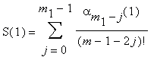

m₁= m/2 , m = 2^{k} , k ≥ 1.

At the first step m/2 integers of the form

αm₁-j(1) = m - 2j , j = 0, 1, … , m₁-1 .

are calculated. After that we act in a similar way: combining on each step the summands of the sum S sequentially in pairs, we take out of the brackets the 'obvious' common factor and compute only the integer values of the expressions in the brackets. Assume that the first i steps of this process are completed.

Step i+1 (i+1 ≤ k).

S = S(i+1);

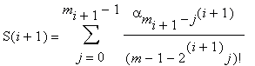

m_{i+1} = m_{i} /2 = m/2^{i+1} ,

we compute only m/2^{i+1} integers of the form

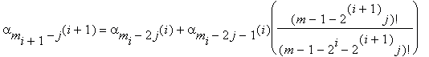

j = 0 , 1 , … , m_{i+1}-1, m = 2^{k} , k ≥ i+1 . Here ((m-1-2^{i+1}j)!/(m-1-2^{i}-2^{i+1}j)!) is the product of 2^{i} integers.

… etc.

Step k , the last one. We compute one integer value α₁(k), we compute, using the fast algorithm described above the value (m-1)!, and make one division of the integer α₁(k) by the integer (m-1)!, with accuracy up to n
digits. The obtained result is the sum S, or the constant e up
to n digits. The complexity of all computations is

O(M(m) log² m) = O(M(n) log n) .

3. The method FEE and the summation of series

The method was called FEE (Fast E-function Evaluation) for the reason that it makes it possible to compute fast the Siegel E -functions, and in particular, e^{x}. A class of functions, which are ‘similar to the exponential function’ was given the name ‘E-functions' by Siegel http://www-groups.dcs.st-and.ac.uk/~history/Mathematicians/Siegel.html [46]. Among these functions are such higher transcendental functions as the hypergeometric function, cylindrical, spherical functions and so on. With the help of the FEE it is possible to compute fast any suitable power series. For example, for fast evaluation of the
constant π, one can use the Euler formula

π/4 = arctan 1/2 + arctan 1/3,

and apply the FEE to sum the Taylor series for

arctan 1/2 = 1/(1*2) – 1/(3*2³) + … + (-1)^{r-1}/((2r-1)2^{2r-1}) + R₁ ,
arctan 1/3 = 1/(1*3) – 1/(3*3³) + … + (-1)^{r-1}/((2r-1)3^{2r-1}) + R₂ ,

with the remainder terms R₁, R₂, which satisfy the bounds

| R₁| ≤ 4/5/(2r+1)/2^{2r+1};
| R₂| ≤ 9/10/(2r+1)/3^{2r+1};

and for r = n, 4(|R₁|+| R₁|) < 2⁻ⁿ.
To calculate π by the FEE it is possible to use also other approximations, for example from [5]. The complexity is

sπ(n) = O(M(n) log²n) .

To compute the Euler constant gamma with accuracy up to n digits, it is necessary to sum by the FEE two series. Namely, for m = 6n, k = n, k ≥ 1,

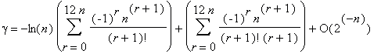

The complexity is

s_{γ}(n) = O(M(n) log²n) .

To evaluate fast the constant γ it is possible to apply the FEE to the approximation from [12].
By the FEE the two following series are calculated fast:

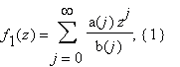

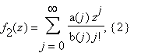

under the assumption that a(j), b(j) are integers, |a(j)|+|b(j)| ≤ (Cj)^{K}; |z| < 1; K and C
are constants, and z is an algebraic number. The complexity of the evaluation of the series (1), (2) is

sf₁(n) = O(M(n) log²n) ,
sf₂(n) = O(M(n) log n) .

4. Calculation of the exponential function by the FEE

Consider y = f(x) = e^{x}. We calculate the function y = e^{x} at the point x = x₀ with accuracy 2⁻ⁿ, assuming first that

0 < x₀ < 1/4 , n > 8. (3)

Take the integer k, satisfying the conditions 2^{k}⁻¹ < n ≤ 2^{k} and set N = 2^{k+}¹ (note that
2n ≤ N < 4n). For x_{N} = α₃2⁻³ + α₄2⁻⁴ + … + α_{N}2⁻^{N}, where α_{j} = 0 or 1, j = 3, 4, … , N, we get

| x₀ - x_{N} | ≤ 2⁻^{N}.
Then
e^{x0} = e^{xN} + 4θ₁ 2⁻^{N} ; | θ₁ | ≤ 1 .

Let us compute e^{xN}. Represent x_{N} in the form

x_{N} = β₂ /2⁴ + β₃ /2⁸ + β₄ /2¹⁶ + … + β_{k+1}/2^{N} ,
where

β₂ = α₃α₄ ; β₃ = α₅α₆α₇α₈ ; … ; β_{k+1} = α_{N – 2}k ₊ ₁α_{N – 2}k ₊ ₂ … α_{N – 1} α_{N} .

Here β_{ν} is a 2^{ν}⁻¹ -digit integer, with 2 ≤ ν ≤ k+1 and k+1 = log N.
Thus, it is possible to represent the number e^{xN} as the product

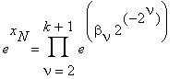

We expand each factor of this product in the Taylor series:

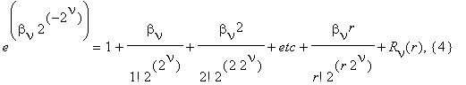
r = N 2⁻ ^{ν+1}.
For the remainder of the Taylor series
R_{ν}(r) the following inequalities are valid:

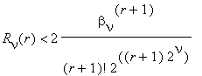
R_{ν}(r) < 2⁻^{N} .
Consequently, it is possible to rewrite (4) in the form

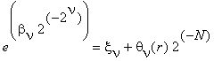
where
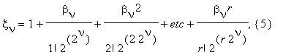

and the constants θ_{ν}(r) satisfy the estimate 0 < θ_{ν}(r) < 1 .
It is easy to see that the sum (5) is suitable for summing by means of the FEE. At the last step of the process we have in (5)

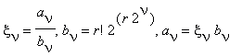

and then we make one division of the integer a_{ν} by the integer b_{ν} with accuracy up to N digits. That is, we obtain η_{ν} such that

ξ_{ν} = a_{ν} /b_{ν} = η_{ν} + θ′_{ν} 2⁻^{N} , | θ′_{ν} | < 1 .

Then e^{xN} can be represented in the form

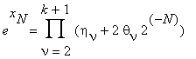
| θ_{ν} | ≤ 1 .

We define the integer l from the inequalities 2^{l}⁻¹ < k ≤ 2^{l}.
Assuming that η_{ν} =1, θ_{ν} = 0 for ν > k, we can rewrite the last relation in the form

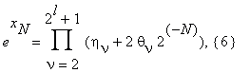
| θ_{ν} | ≤ 1 .
It is clear that log k ≤ l < log k + 1.
The last product is computed in l steps of the process, which is similar to calculating n!. We multiply the factors of (6) sequentially in pairs, computing at the first step 2^{l}⁻¹ products of the form

(η_{ν} + 2 θ_{ν} 2⁻^{N}) (η_{ν +1} + 2 θ_{ν+1} 2⁻^{N}) = η_{ν} η_{ν +1} + 2 θ_{ν} 2⁻^{N}η_{ν +1} + 2 θ_{ν+1} 2⁻^{N} η_{ν} + 4θ_{ν}θ_{ν+1} 2⁻^{2N} = η_{ν ,ν +1} + 8 θ_{ν,ν+1} 2⁻^{N},
ν ≡ 0(2) , ν = 2, 3, … , 2^{l} + 1,

where η_{ν ,ν +1} is the N –digit integer such that

η_{ν ,ν +1} = η_{ν} η_{ν +1} + θ̃ 2⁻^{N} , | θ̃ | ≤ 1 , | θ_{ν ,ν+1}| ≤ 1.

Here we take into account that | η_{ν} | < e^{xN} < e^{x0} < 3/2 .
After the 1-st step of this process the product (6) takes the form:

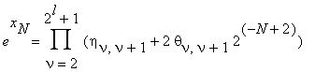
ν ≡ 0(2)
| θ_{ν ,ν+1}| ≤ 1.

Further we act in a similar way.
After the 2-nd step of this process the product (6) takes the form:

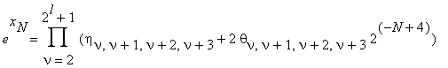
ν ≡ 2(4)
| θ_{ν,ν+1,ν+2,ν+3}| ≤ 1.
… etc.

In l steps we obtain

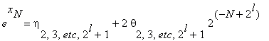
| θ_{2, …, 2}l ₊ ₁ | ≤ 1.
Since l < log k +1, k = log N - 1, 2n ≤ N < 4n, we find from the last relation that

e^{x0} = η + θ 2⁻^{n} ,
where η = η_{2, …, 2}l ₊ ₁ , | θ | ≤ 1.
The complexity of the computation of e^{x0} with the
help of this process is

O(M(n) log²n) .

Remark 1. We considered the case 0 < x₀ < 1/4. If x₀ ≥ 1/4, then we take the least integer m such that m > 4x₀.
In this case 0 < x₀/m < 1/4 , e^{x0} = (e^{x0/ m})^{m}. Thus evaluation of e^{x0} is reduced to evaluation of e^{x0/ m} ,
0 < x₀ /m < 1/4, and to taking the m -th power of the result. This doesn't make the bound worse, because m is a fixed number.

5. Calculation of the trigonometric functions by the FEE

Computation of the trigonometric functions y = f(x) = sin x and y = f(x) = cos x at the point x = x₀ can be reduced to the computation of real and imaginary parts of e^{ix0}. We represent the number x_{N} in the same form as in the previous case, then e^{ix0} = e^{ixN} + 4θ₁ 2⁻^{N} ,

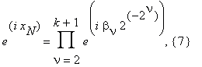
| θ₁ | ≤ 1 .

We write

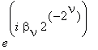

in the form
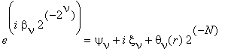

where
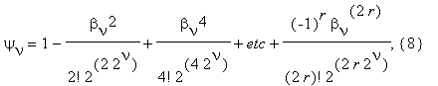

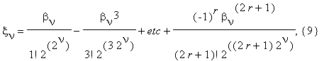

- < θ_{ν}(r) < 1.

Then we perform with the sums (8), (9) the same actions as with the sum (4). Let η_{ν}, φ_{ν} be N –digit integers such that

ξ_{ν} = a′_{ν} /b_{ν} = η_{ν} + θ′_{ν} 2⁻^{N} , | θ′_{ν} | ≤ 1,
ψ_{ν} = a″_{ν} /d_{ν} = φ_{ν} + θ″_{ν} 2⁻^{N} , | θ″_{ν} | ≤ 1,

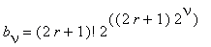, 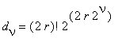

Then (7) can be represented in the form

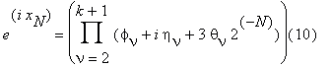
| θ_{ν} | ≤ 1 .
We compute the product (10) by means of the process which is described in the previous paragraph. As a result we find with specially chosen l , N , r

e^{ix0} = φ + i η + 2θ 2⁻^{N} , | θ | ≤ 1 ,
whence

cos x₀ = φ + θ₁ 2⁻^{n} , | θ₁| ≤ 1 ,
sin x₀ = η + θ₂ 2⁻^{n} , | θ₂ | ≤ 1 .

The complexity of the evaluation is the same as for the exponential function:

O(M(n) log²n).

In [25] the following general theorem is proved:

Theorem. Let y=f(x) be an elementary transcendental function, that is the exponential function, or a trigonometric
function, or an elementary algebraic function, or their superposition, or their inverse, or a superposition of the inverses. Then

s_{f}(n) = O(M(n) log²n) .

6. Fast evaluation of the Euler gamma function for a rational value of the argument

The Euler gamma function y = Γ(s), is one of those higher transcendental functions, that, being not Siegel E-functions, at the same time can be calculated fast by the FEE. There are two algorithms for the evaluation of Γ(s):
1) for rational values of the argument s ; 2) for algebraic values of the argument s. The first of these algorithms is more 'simple' than the second one. We compute the function y = Γ(x) , for x = x₀ = a/b ; (a,b) = 1,
assuming at first that 0 < x₀ < 1, that is 0 < a < b. We use the representation of the
gamma function in the form of the integral

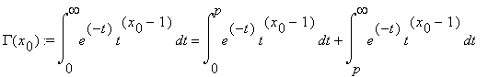

It is easy to see that for p = n, 0 < x₀ < 1,

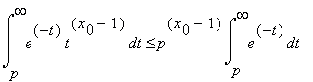

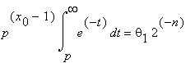 , 0 < θ₁ < 3/4.

Hence,

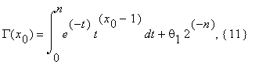
0 < θ₁ < 3/4.

Assuming that r ≥ 3n, we expand the integrand in (11) in the Taylor series in powers of t:

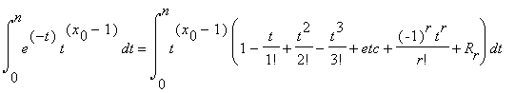

where R_{r} = θ_{r} t^{r+1}/(r+1)!, | θ_{r} | ≤ 1. From here we have for r+1 = 6n

Γ(x₀) = n^{x0} S + θ 2⁻^{n} , | θ | ≤ 1 , (12)
where
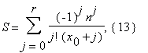

and we will calculate Γ(x₀) = Γ(a/b) by (12)--(13). We note, that for the calculation of the value n^{x0} = n^{a/b}, with accuracy up to n digits, O(M(n)) operations are sufficient (by the Newton method). For the calculation of the sum S we take r+1 = 2^{k}, 2^{k}⁻¹ < 6n ≤ 2^{k}, k ≥ 1; terms of the series (13). We set

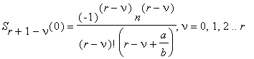

Then it is possible to rewrite (13) in the form

S = S₁(0) + S₂(0) + … + S_{r+1}(0) .

We compute the sum S by the FEE in k steps, combining at each step the summands of S sequentially in pairs and taking out of the brackets the 'obvious' common factor. However, unlike the computation of the constant e, now in each pair of the brackets there are fractions, not integers . So that at each step we calculate the integer numerator and the integer denominator of the fraction, sitting in each pair of brackets (we do not divide until the last step). At the first step we have

S = S₁(1) + S₂(1) + … + Sr₁(1) , r₁ = (r+1)/2

Sr₁-ν(1) = Sr+1-2ν(0) + Sr-2ν(0) = (-1)^{r}⁻¹n ^{r}⁻ ^{2 ν}⁻¹/(r-2ν)! (pr₁-ν(1)/qr₁-ν(1)) .

At the 1-st step we calculate the integers

pr₁-ν(1) = - bn(br-2bν -b+a) + (br-2bν)(br-2bν +a) ;
qr₁-ν(1) = (br-2bν +a)(br-2bν -b+a) ;
ν = 0 , 1 , … , (r+1)/2-1 ; r+1 = 2^{k} , k ≥ 1.

At the j -th step (j ≤ k ) we have

S = S₁(j) + S₂(j) + … + Sr_{j}(j) , r_{j} = (r+1)/2^{j}

where Sr_{j}-ν (j); ν = 0 , 1 , … , r_{j} -1 ; are defined by the equalities

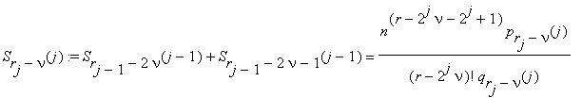

At the j -th step (j ≤ k) we calculate the integers

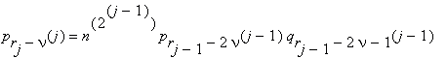
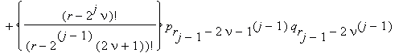

ν = 0 , 1 , … , r_{j} -1 ; r_{j} = (r+1)/ 2^{j}.

… etc.

At the k-th (the last) step we calculate the integers pr_{k}(k) = p₁(k), qr_{k}(k) = q₁(k), r! and make one division with accuracy 2⁻^{2n} by the formula

S = S₁ (k) = pr_{k}(k)/qr_{k}(k)/r! ,

which gives the sum S with accuracy 2⁻^{n}⁻¹ . Hence Γ(x₀) = Γ(a/b) is calculated with accuracy
2⁻^{n+1}, n ≥ 1. The complexity of such calculation is

s Γ (n) = O(M(n) log²n) = O(n log³n loglog n).

Remark 2. We evaluated Γ(x₀), x₀ = a/b, assuming that 0 < x₀ < 1. If x₀ ≥ 1, then using the relation
Γ(x+1) = xΓ(x), we reduce this calculation to the calculation at the point from the interval (0,1).

7. Fast evaluation of the Euler gamma function for an algebraic argument

We shall evaluate Γ(x₀), where x₀ is an algebraic number. As in Remark 2, we reduce this computation to the computation of Γ(α), 0 < α < 1, where α is an algebraic number. For simplicity, here we consider
the case, where α is a real number of degree μ, μ ≥ 2. We assume that we know g(x), the polynomial of the
least degree with integer coefficients, whose root is α, that is

g(x) = g_{μ} x^{μ} + g_{μ-1}x^{μ}⁻¹ + … + g₁x + g₀ ; g(α) = 0 ; (14)

g_{μ},g_{μ-1,} …,g₀ are integers, μ ≥ 2. As in the case of rational argument, we use (12), (13).
We note that the computation of the value n^{α} with accuracy 2⁻^{2n} by formula n^{α} = e^{α log n} requires
O(M(n) log²n) operations. The sum S from (12) takes the form

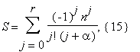

that is
S = S₁(0) + S₂(0) + … + S_{r+1}(0) , (16)

where
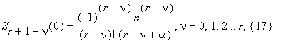

The computation of S is realized in k steps, r+1 = 2^{k}, 2^{k}⁻¹ < 6n ≤ 2^{k}, k ≥ 1.
The peculiarity of this algorithm is that we use the main property of algebraic numbers to bound the growth of
the computational complexity. Before the step i, where i is determined from the conditions 1 ≤ i ≤ k ,
2^{i}⁻¹ < μ ≤ 2^{i}, we perform with the sum (16), (17) the actions similar to the ones described above for the case of rational argument. However, arranging the terms of the sum (16) in groups in the same way as in the previous
paragraph, what we calculate at each step now is not the numerator and the denominator of the fractions which are ‘in brackets’, but only the integer coefficients of the powers of α, of the polynomials in the numerators and denominators of the fractions ‘in brackets’.

At the 1-st step in brackets there are the numbers

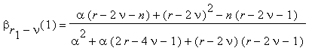

and we calculate the integers

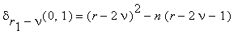

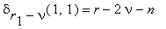

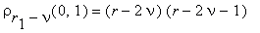

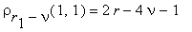
ν = 0 , 1 , … , (r+1)/2-1.
At i -th step in brackets there are the numbers

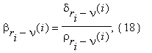
where
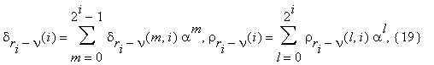

and we calculate the integers

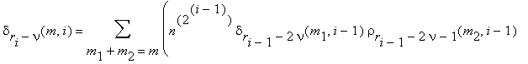
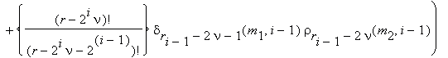
0 ≤ m ₁ ≤ 2^{i}⁻¹-1 , 0 ≤ m ₂ ≤ 2^{i}⁻¹.
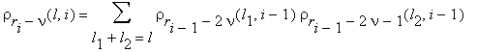
0 ≤ l ₁ ≤ 2^{i}⁻¹ , 0 ≤ l ₂ ≤ 2^{i}⁻¹.
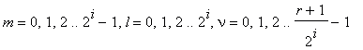

Note that the multiplication by the power of α and the computation of δ and ρ, also the division of δ by ρ, are not produced till the last step.
Before the i+1 -st step (1 ≤ i ≤ k , 2^{i}⁻¹ < μ ≤ 2^{i}) we reduce the polynomials (19) modulo polynomial g(x) for x = α.Thus, if

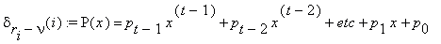

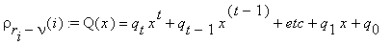

where p_{t-1}, …,p₀, q_{t} ,…,q₀ are integers, t = 2^{i}, then we divide P(x) and Q(x) by g(x) with the remainders:

P(x) = g(x)P₀(x) + P₁(x) , Q(x) = g(x)Q₀(x) + Q₁(x) ,

where P₁(x) and Q₁(x) are the polynomials with rational coefficients, and the degrees of the polynomials P₁(x) and Q₁(x) are not greater than μ-1. From here and from (14) we obtain that

P(α) = P₁(α), Q(α) = Q₁(α),

that is, in (18) we get

βr_{i}-ν(i) = P₁(α)/Q₁(α) . (20)

Multiplying, if necessary the numerator and the denominator of the fraction (20) by an integer common factor, we get in the numerator and the denominator of the fractions 'in brackets' the polynomials with integer coefficients of degree not higher than μ-1. Starting with i, at each step i, i+1, …, k, we reduce the polynomials in α, sitting in the numerator and the denominator of βξ(j) modulo g(x). Since the coefficients of g(x) and the degree of g(x) are the absolute constants, we conclude that the values of these coefficients, participating in the reductions described above can increase in at most g^{μ} times, where

g = max 0≤i ≤μ |g _{i}|,

what does not make any influence on the bound of the complexity of the calculations we perform. At the last, k -th, step of this process we get

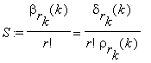

where
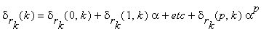

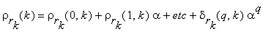

p, q ≤ μ-1, and we calculate δr_{k}(k), ρr_{k}(k) and S, and consequently Γ(α) with accuracy 2⁻^{n+1}. The complexity of the computation

s Γ (n) = O(M(n) log²n)

8. Conclusion

The presented method FEE, the method of fast summation of series of a special form, permits to compute any elementary transcendental function for any value of the argument, the classical constants e, π, the Euler constant γ, the Catalan and the Apery constants, such higher transcendental functions as the Euler gamma function and it's derivatives, the hypergeometric, spherical, cylindrical and other functions for algebraic values of the argument and parameters, the Riemann zeta function for integer values of the argument and the Hurwitz zeta function for integer argument and algebraic values of the parameter, and also such special integrals as the integral of probability, the Fresnel integrals, the integral exponential function, the integral sine and cosine, and some other integrals for algebraic values of the argument with the complexity bound which is close to the optimal one, namely

s_{f}(n) = O(M(n) log²n) .

At present, only the FEE makes it possible to calculate fast the values of the functions from the class of higher transcendental functions, certain special integrals of mathematical physics and such classical constants as Euler's, Catalan's and Apery's constants. An additional advantage of the method FEE is the possibility of parallelizing the algorithms based on the FEE.

References

[1] V.B.Alekseev, From the Karatsuba Method for Fast Multiplication of Numbers to Fast Algorithms for Discrete Functions. Proceddings of the Steklov Inst.of Math., v. 218, pp.15-22 (1997).

[2] V.B.Alekseev, S.A.Lozkin, Elements of graph theory, circuits and automata. Publ. VMK MGU, 58 pp., Moscow (2000).

[3] G.N.Arkhipov, V.N. Chubarikov, V.A. Sadovnichii, Lectures in Mathematical Analysis. Publ. 'Vysshaya Shkola',
695 pp., Moscow (1999).

[4] E.Bach, The complexity of number-theoretic constants. Info.Proc.Letters, N 62, pp.145-152 (1997).

[5] D.H.Bailey, P.B.Borwein and S.Plouffe, On the rapid computation of various polylogarithmic constants.
Math. Comp.,v. 66, pp.903-913 (1997).

[6] J.C.Bajard, J.M.Muller, Calcul et arithmétique des ordinateurs. Hermes Science, 226 pp. (2004).

[7] L.A.Bassalygo, Note on fast multiplication of polynomials over Galois fields.
Probl. of Inform.Transm., 14 (1), pp.71-72 (1978).

[8] Benderskij Yu.V., Fast Computations. Dokl.Akad.Nauk SSSR, v.223, N 5, pp.1041-1043 (1975).

[9] J.M.Borwein and P.B.Borwein, Pi and the AGM. Wiley, 414 pp., New York (1987).

[10] J.M.Borwein, D.M.Bradley and R.E.Crandall, Computational strategies for the Riemann zeta function.
J. of Comput. Appl. Math., v. 121, N 1-2, pp.247-296 (2000).

[11] R.P.Brent, Fast Multiple-Precision Evaluation of Elementary Functions. ACM, v.23, N 2, pp.242-251 (1976).

[12] R.P.Brent and E.M.McMillan, Some new algorithms for high-precision computation of Euler's constant.
Math. Comp., v.34, pp.305-312 (1980).

[13] B.C.Carlson, Algorithms involving arithmetic and geometric means. Amer. Math. Monthly, v.78, pp.496-505 (1971).

[14] B.C.Carlson, An algorithm for computing logarithms and arctangents. Math.Comp., v.26, pp.543-549 (1972).

[15] S.A.Cook, On the minimum computation time of functions. Thesis, Harvard University (1966).

[16] D.Coppersmith and S.Winograd, On the asymptotic complexity of matrix multiplication. SIAM Journal on Computing, v.11, N 3, pp.472-492 (1982).

[17] S.B.Gashkov, On the Complexity of Integration of Rational Fractions. Proceedings of the Steklov Inst.of Math.,
v. 218, pp.122-133 (1997).

[18] S.B.Gashkov, V.N. Chubarikov, Arithmetics. Algorithms. The Complexity of Computations. Publ. 'Vysshaya Shkola', 2-d ed., 320 pp., Moscow (2000).

[19] Karatsuba A. and Ofman Yu., Multiplication of Multiplace Numbers on Automata. Dokl.Akad.Nauk SSSR, v.145, N 2, pp.293-294 (1962).

[20] A.Karacuba, Berechnungen und die Kompliziertheit von Beziehungen. EIK, N 11, pp.10-12 (1975).

[21] A.A.Karatsuba, The Complexity of Computations. Proceedings of the Steklov Institute of Mathematics, v.211, pp.169-183 (1995).

[22] Karatsuba E.A., Fast computation of exp(x). Problems of Information Transmission, v. 26, N 3, p. 109, Chronicle-17th All-Union School on Theory of Information and its Applications (1990).

[23] Karatsuba E.A., On a new method for fast evaluation of transcendental functions. Uspechi Mat. Nauk, v. 46, N 2 (278), pp. 219--220 (1991).

[24] Karatsuba E.A., On the fast computation of transcendental functions. Doklady Akad. Nauk SSSR, v. 319, N 2, pp. 278--279 (1991).

[25] Karatsuba E.A., Fast evaluations of transcendental functions. Probl. Peredachi Informat., v. 27, N 4, pp. 87—110 (1991).

[26] Karatsuba E.A., Fast evaluation of ζ(3), Probl. Peredachi Informat., v. 29, N 1, pp. 68--73 (1993).

[27] Catherine A.Karatsuba, Fast evaluation of Bessel functions. Integral Transforms and Special Functions, v.1,
N 4, pp. 269-276 (1993).

[28] Karatsuba E.A., Fast Evaluation of Riemann zeta-function ζ(s) for integer values of argument s. Probl. Peredachi Informat., v. 31, N 4, pp. 69--80 (1995).

[29] Karatsuba E.A., On fast computation of Riemann zeta-function for integer values of argument. Doklady RAS, v. 349, N 4, p.463 (1996).

[30] Karatsuba E.A., Fast evaluation of Hurwitz zeta function and Dirichlet L -series, Problem. Peredachi Informat., v. 34, N 4, pp. 342--353 (1998).

[31] Ekatharine A. Karatsuba, Fast evaluation of hypergeometric function by FEE. Computational Methods and Function Theory (CMFT'97),
N.Papamichael, St.Ruscheweyh and E.B.Saff, eds., World Sc.Pub., pp. 303-314 (1999).

[32] E.A.Karatsuba, On the computation of the Euler constant gamma. University of Helsinki preprint, 21 pp. (1999);
J. of Numerical Algorithms, v. 24, pp.83-97 (2000).

[33] E.A.Karatsuba, Fast computation of ζ(3) and of some special integrals, using the polylogarithms, the Ramanujan formula and it's generalization. J. of Numerical Mathematics BIT, v. 41, N 4, pp.722-730 (2001).

[34] E.A.Karatsuba, Fast computation of some special integrals of mathematical physics. Scientific Computing, Validated Numerics, Interval Methods, W.Krämer,J.W.von Gudenberg,eds., pp.29-41 (2001).

[35] D.E.Knuth, The art of computer programming. v.2 Addison-Wesley Publ.Co., 724 pp., Reading (1969).

[36] A.N.Kolmogorov, Asymptotic characteristics of some completely bounded metric spaces. Dokl. Akad. Nauk SSSR, v.108, N 3, pp.385-388 (1956).

[37] A.N. Kolmogorov, Information Theory and the Theory of Algorithms. Publ. Nauka, 303 pp., Moscow (1987).

[38] J.Landen, An investigation of a general theorem for finding the length of any arc of any conic hyperbola, by means of two elliptic arcs, with some other new and useful theorems deduced therefrom. Philos.Trans.Royal Soc. London, v. 65, pp.283-289 (1775).

[39] D.W.Lozier and F.W.J.Olver, Numerical Evaluation of Special Functions. Mathematics of Computation 1943-1993: A Half -Century of Computational Mathematics, W.Gautschi,eds., Proc. Sympos. Applied Mathematics, AMS, v.48, pp.79-125 (1994).

[40] V.I.Nechaev, Elements of Cryptography. Basic Protection Information Theory. Publ. 'Vysshaya Shkola', 110 pp., Moscow (1999).

[41] V.Ya.Pan, Strassen's algorithm is not optimal. Proc. ACM Symp. on the Found. of Comp.Science, pp.166-176 (1978).

[42] E.Salamin, Computation of π using arithmetic-geometric mean. Math. Comp., v.30, N 135, pp.565-570 (1976).

[43] A.Schőnhage, Schnelle Multiplikation grosser Zahlen. Computing, v.1, pp.182-196 (1966).

[44] A.Schőnhage und V.Strassen, Schnelle Multiplikation grosser Zahlen. Computing, v.7, pp.281-292 (1971).

[45] A.Schőnhage, A.F.W.Grotefeld and E.Vetter, Fast Algorithms. BI-Wiss.-Verl., 300 pp., Zűrich (1994).

[46] C.L.Siegel, Transcendental numbers. Princeton University Press, 102 pp., Princeton (1949).

[47] V.Strassen, Gaussian elimination is not optimal. J. Numer. Math., N 13, pp.354-356 (1969).

[48] A.L.Toom, The complexity of a scheme of functional elements realising the multiplication of integers.
Dokl.Akad.Nauk SSSR, v.150, N 3, pp.496-498 (1963).

J

Answers to the frequently asked (mainly by computer scientists) questions

About the FEE see E.A.Karatsuba's paper:
'Fast evaluation of Hurwitz zeta function and Dirichlet L-series'.

© Ekatherina Karatsuba
Last correction: June 28, 2005.

